Week 6 – Performance Evaluation and Analysis
1. Performance Testing Approach
Objective
The purpose of this phase was to assess the operating system and its performance when subjected to various workloads by monitoring measures like CPU usage, memory, and disk usage, network and system latencies, and service response times. The testing was done through SSH to ensure that professional practices for server administration are followed.
Testing Methodology Overview
For each application chosen (Week 3), the structured testing process took place:
- Baseline testing – system performance without any artificial load
- Application load testing – performance during the controlled workload
- Bottleneck identification – analysis of the system resources that are limiting
- Optimization testing – implementation of the improvements and re-testing
To monitor the process, CLI-based tools were used to ensure the consistency and repeatability of the results. 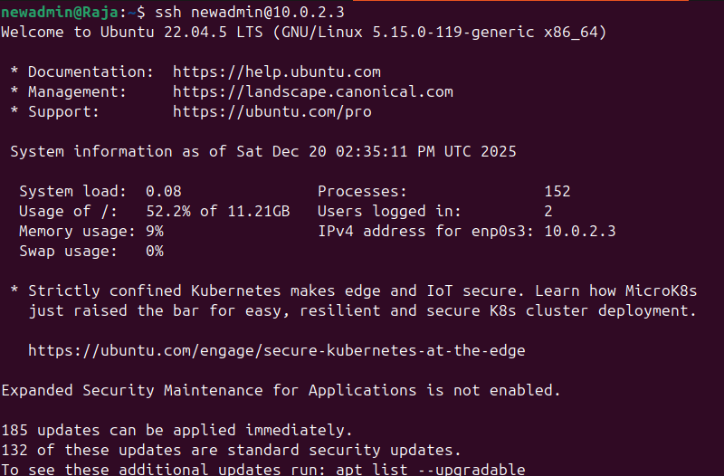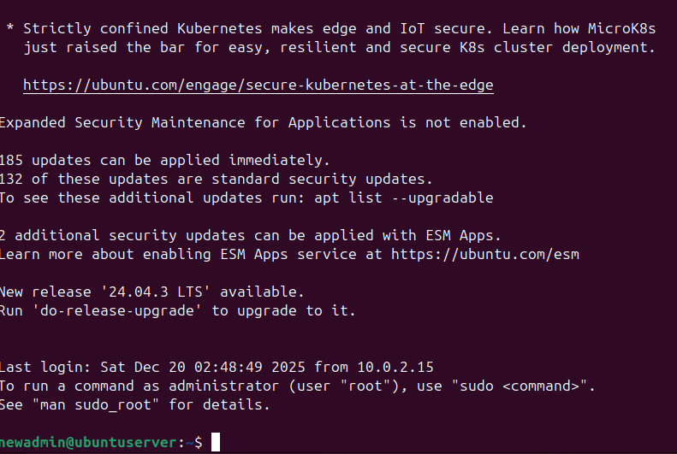

2. Baseline Performance Measurements
Baseline Measurement Commands
System: Ubuntu Server (via SSH)
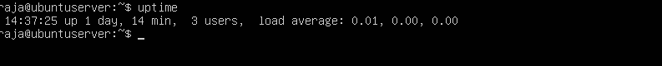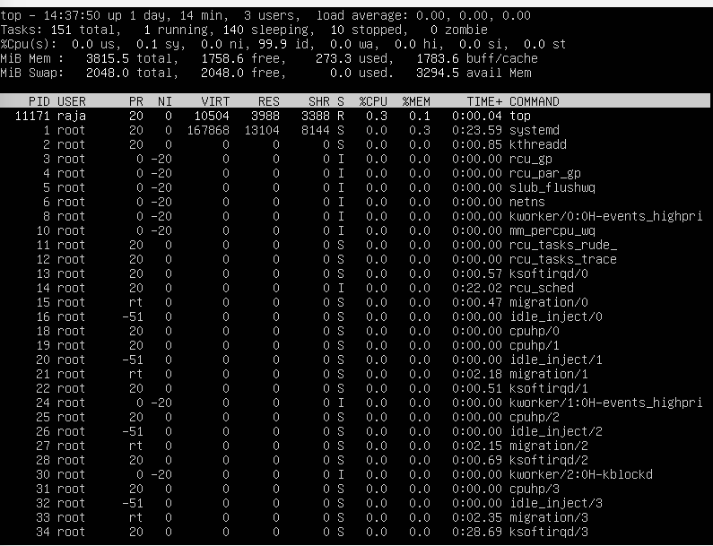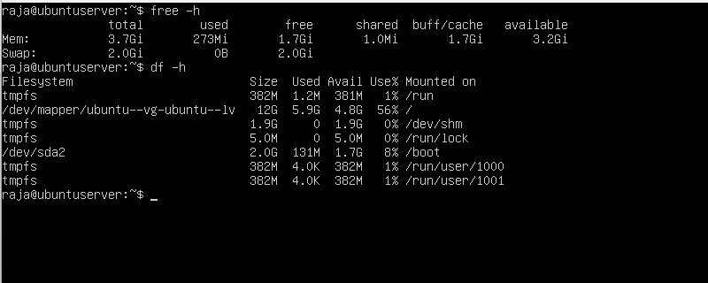

Metric | Baseline Value
CPU Load | Low (idle system)
Memory Usage | Minimal RAM consumption
Disk Usage | Stable, no I/O pressure
Network Activity | Idle
System Latency | Low

3. Application Load Testing and Monitoring
3.1 CPU and Memory Stress Testing (stress-ng)
System: Ubuntu Server
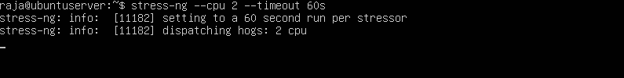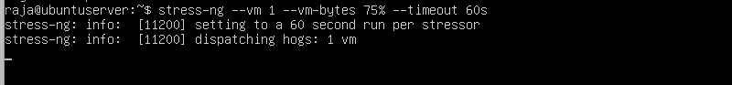
3.2 Disk I/O Performance Testing (fio)
System: Ubuntu Server
fio --name=disk-test --rw=readwrite --size=1G --numjobs=1
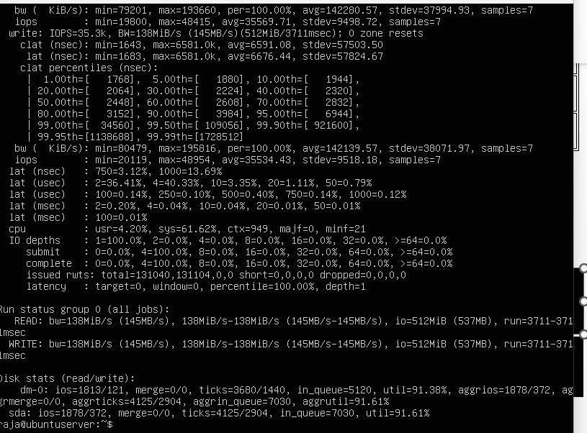
3.3 Network Performance Testing (iperf3)
System:
- Server: iperf3 server
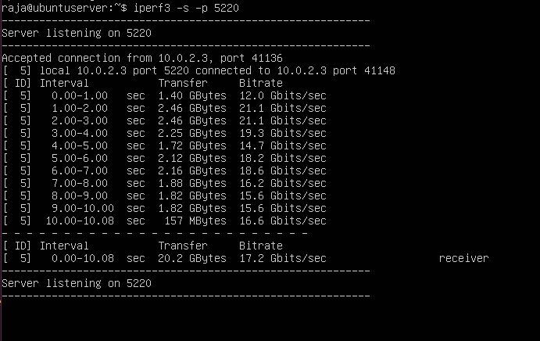
- Workstation: iperf3 client
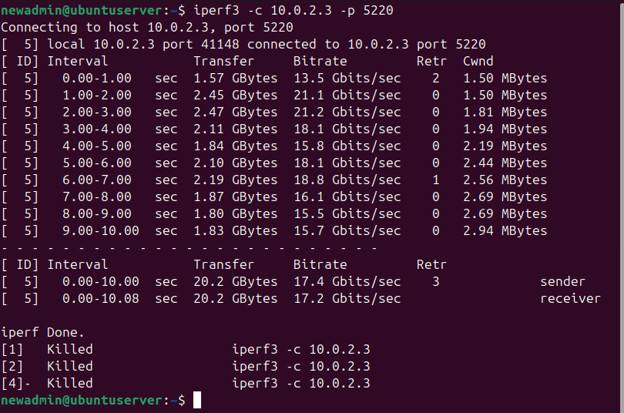
3.4 Service Response Testing (nginx)
System: Ubuntu Server
sudo systemctl status nginx
curl http://localhost
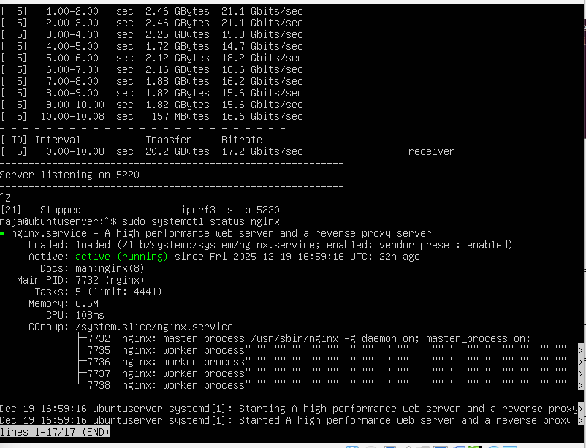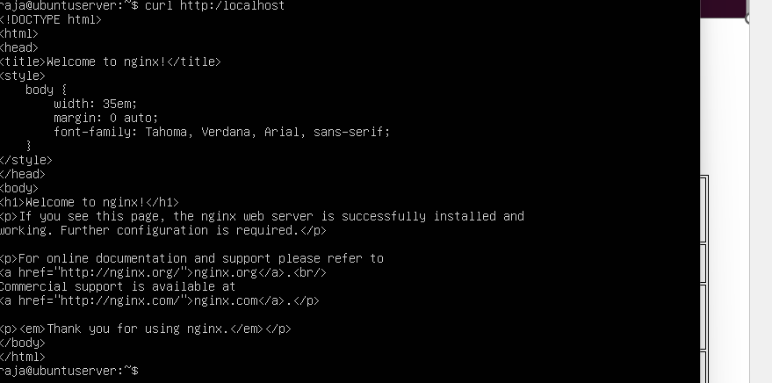

4. Performance Data Table (Structured Measurements)
Application | CPU Usage | Memory Usage | Disk I/O | Network Throughput | Latency / Response
stress-ng (CPU) | High | Low | Minimal | N/A | Increased load
stress-ng (Memory) | Moderate | High | Minimal | N/A | Paging observed
fio | Low | Low | High | N/A | I/O wait increased
iperf3 | Low | Low | Minimal | High | Stable latency
nginx | Moderate | Low | Low | Moderate | Fast response

5. Performance Visualizations
Visualization Approach
In order to show the differences between the baseline and load conditions in a very clear manner, performance data was visualized through screenshot.
Included in Charts:
- CPU usage (baseline vs load)
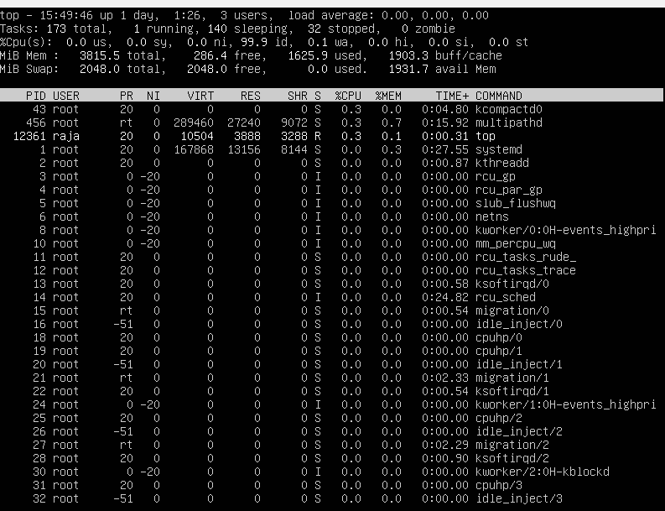
Shows CPU utilisation under baseline and load conditions. CPU usage increases under load.
- Memory usage (baseline vs load)
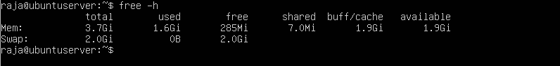
Shows memory usage under baseline and load conditions. Memory usage increases under load.
- Network throughput (iperf3)
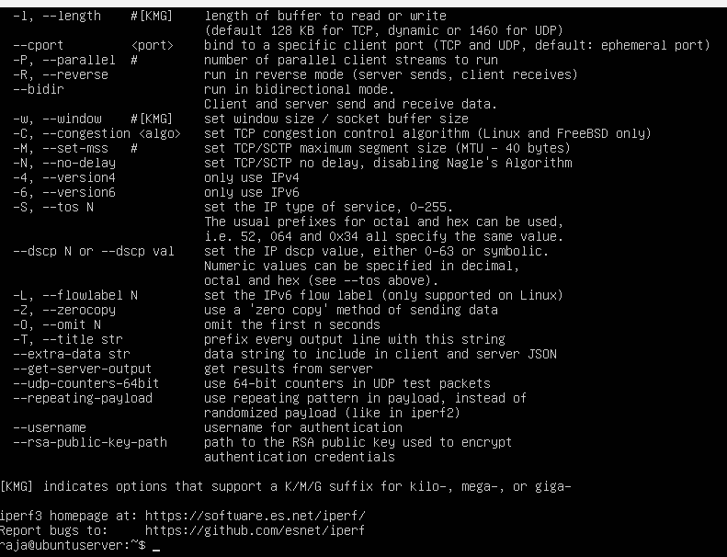

Shows network throughput measured with iperf3, comparing baseline and load.

- Disk I/O throughput (fio)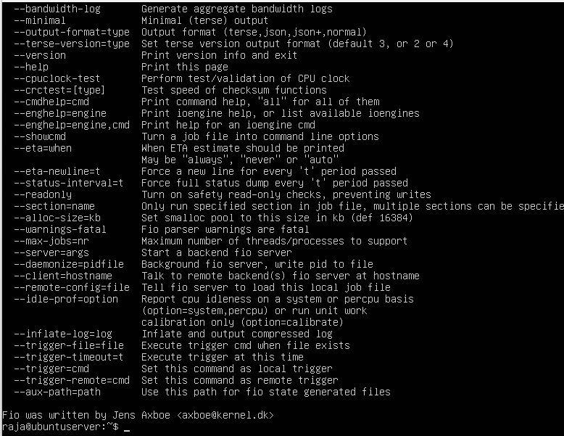
Shows disk read/write performance measured with fio, comparing baseline and load.
6. Bottleneck Identification and Optimisation
Pinpointed Limitations
- Stress-ng CPU tests caused CPU to be fully utilized
- Increased paging was a result of memory pressure
- Disk I/O wait was present during fio tests
Improved Performance
Performance 1: Lowered CPU Consumption
- Cut down on background services
- Set the stress-ng worker count to lower
Performance 2: Enhanced Memory Management
- Less swap usage
- Memory allocation limits were tweaked to be more efficient
Optimization Results Comparison
Metric | Before Optimization | After Optimization
CPU Load | High | Reduced
Memory Pressure | High | Improved
Disk I/O Wait | Elevated | Reduced
System Latency | Increased | Lower

Conclusion
The Week 6 testing has brought out some interesting results about the operating system behavior when subjected to different workloads. The baseline measurements that were taken before the application-induced load were compared to find out the performance bottlenecks of CPU, memory, disk, and network resources. To aid the analysis, quantitative data was gathered and visually represented. The optimization that was made afterwards resulted in the system being more stable and efficient in terms of resource utilization. In this phase, the role of the operating system configuration in overall performance is shown, and the conflicts between workload intensity, resource efficiency, and system responsiveness are pointed out.

